

# CSE 307 System Analysis and Design (Spring 2019)

# **GROUP MEMBERS**

* **Sadek Hossen Leon (1521818)**

**TABLE OF CONTENTS**

**SECTION 1............................................................................................................................... 4**

**INTRODUCTION................................................................................................................ 4**

**HISTORY LEADING TO PROJECT REQUEST ........................................................... 4**

**PROBLEM, SOLUTION AND OPPORTUNITIES ........................................................ 4**

**PROBLEM ....................................................................................................................... 4 SOLUTION ...................................................................................................................... 5**

**OPPORTUNITIES .......................................................................................................... 5**

**PROJECT GOAL AND OBJECTIVES ............................................................................ 5**

**GOALS.............................................................................................................................. 5**

**OBJECTIVES .................................................................................................................. 5**

**SECTION 2............................................................................................................................... 6**

**PRODUCT DESCRIPTION ............................................................................................... 6**

**PRODUCT SUMMARY ................................................................................................. 6**

**PRODUCT STAKEHOLDERS ...................................................................................... 6**

**CONTEXT LEVEL DATA FLOW DIAGRAM ............................................................... 7**

**HARDWARE DETAILS ..................................................................................................... 7**

**KEY TECHNICAL FEATURES OF SOFTWARE ......................................................... 8**

**SOFTWARE DETAILS .................................................................................................. 9**

**SECTION 3............................................................................................................................... 9**

**INFORMATION GATHERING METHODS .................................................................. 9**

**INTERVIEWING .......................................................................................................... 10**

**SURVEYING PEOPLE THROUGH QUESTIONNAIRES ..................................... 11**

**SAMPLING .................................................................................................................... 13**

**MAJOR FUNCTIONALITIES OFFERED BY THE SYSTEM ................................... 15**

**USE CASE DIAGRAM ..................................................................................................... 15 NORMAL SCENARIOS FOR USE CASES ................................................................... 16**

**ALTERNATE SCENARIOS FOR USE CASES ............................................................ 17**

**FUNCTIONAL REQUIREMENTS ................................................................................. 18**

**NON-FUNCTIONAL REQUIREMENTS....................................................................... 19**

**SECTION 4............................................................................................................................. 21**

**ENTITY RELATIONSHIP DIAGRAM ......................................................................... 21**

**LOGICAL DATA FLOW DIAGRAM ............................................................................ 22**

**PHYSICAL DATA FLOW DIAGRAM .......................................................................... 27**

**ACTIVITY DIAGRAMS FROM USE CASE DIAGRAMS ......................................... 31**

**SEQUENCE AND COMMUNICATION DIAGRAMS ................................................. 33**

**SEQUENCE DIAGRAM............................................................................................... 33**

**COMMUNICATION DIAGRAM ................................................................................ 36**

**CLASS DIAGRAMS ......................................................................................................... 40**

**STATE CHART DIAGRAMS .......................................................................................... 41**

**CRUD MATRIX ................................................................................................................ 44**

**SECTION 5............................................................................................................................. 45**

**STRUCTURED ENGLISH PSEUDO CODE FOR THE SYSTEM ............................. 45**

**FOR GETTING APPOINTMENT .............................................................................. 45**

**PHARMACY .................................................................................................................. 45**

**TEST ............................................................................................................................... 46**

**NORMALIZED RATIONAL DATABASE TABLES ................................................... 46**

**INTERFACE PROTOTYPING ....................................................................................... 48**



## SECTION 1

### INTRODUCTION



I choose “Digital Health Care System” as my project which is an automated token system for doctor consultation and so on.

### HISTORY LEADING TO PROJECT REQUEST

Our hospital service system is not in our favor every time. Most of the time people have to wait for the health care service for a long time and most of the time it is seen that after waiting for a long they didn’t even get the service. One day in a certain visit to a prominent hospital I observed that there were long queues of the patient for taking their health care services and it was also observed that the patients were looking very anxious and worrying whether they would get their desired service from the hospital by a day. This event struck me and I want to find a way out of this sort of problems. After a deep thought on this issues an idea was generated from my brain which might be an innovative idea. The idea is to introduce a “Digital Health Care System’’ as a token system to confront the problem found in that hospital. From that, I decided to initiate a project of introducing this “Digital Health Care System”.

### PROBLEM, SOLUTION AND OPPORTUNITIES



#### PROBLEM

* The manual system of making token for health care is time consuming because employees must record information manually.
* As it is said it is a token system so there is a chance of issuance of same token number twice.
* The manual system is comparatively costly because of employing a high frequency of human resource for quick response to the patients.
* There is a chance of chaos as lots of patients standing in the queue for a long time which might cause disruption.
* It is labor-intensive job because of managing long queues of patients.
* Because of monotonous job of employees engaged in manual recording of patients’ information for issuing token hence productivity and efficiency decreases.

#### SOLUTION

The solution of the above-mentioned problems is automation of token system project that is proposed herein. If this project initiative is undertaken the aforesaid problems and issues can be redressed such as, the replacement of automation will remove the time consuming and labor intensive manual system. Thus, it will result in less number of employee requirement, low cost and improving efficiency which will impact on maximizing customer (patient) satisfaction and profit of the organization.

#### OPPORTUNITIES

* It can be upgraded and customized easily.
* It will provide premium service to the organization thus comparative advantage can be obtained.
* It will provide 1-year free maintenance service and two weeks training for operating the system.
* It can also be used in any service provider like bank, transportation service or any other service providing centers.

### PROJECT GOAL AND OBJECTIVES



#### GOALS

* Maximizing the profit through increasing service volume of the hospital in exchange of fees.
* Maximizing patient satisfaction through their expectations & needs to see doctors at a minimal loss of time.
* Minimizing the activities of the worker because most of the work will be done by the Digital Health Care system.

#### OBJECTIVES

* To reduce user or patients waiting time on long queues.
* To providing quick responses.
* To reduce human labor and cost.
* To provide comfort in receiving service by the patient.
* To improve service efficiency.

## SECTION 2

### PRODUCT DESCRIPTION



#### PRODUCT SUMMARY

A digital health care system is an automated token dispensing device for people visiting medium and large institution like hospital, by having an digital system it reduces the number of staffs needed to handle people and eliminates hassles as people won’t be able to cut lines or be favored over others. This product maintains and stores data for available time slot of the doctors and provides relevant information using the “help desk” feature of the product. It will prioritize the patients’ emergencies and increase efficiency as well because it can sort patients into different categories according to their need and expectation. It can also retrieve information about available medicines in the pharmacy that helps to make customers life easier as they can check the availability of required medicines rather than going to the pharmacy physically.

#### PRODUCT STAKEHOLDERS

* Patients – the people who mainly use the product.
* Hospital - the client of the product who will buy the product for their hospital.
* Software and hardware provider – the organization who are involved in making the software and building the machine mainly the developers.
* Governmental regulatory agencies – the organizations that are responsible for overseeing and monitoring the compliance issues applicable in the information and communication technology.

### CONTEXT LEVEL DATA FLOW DIAGRAM



**HARDWARE DETAILS**

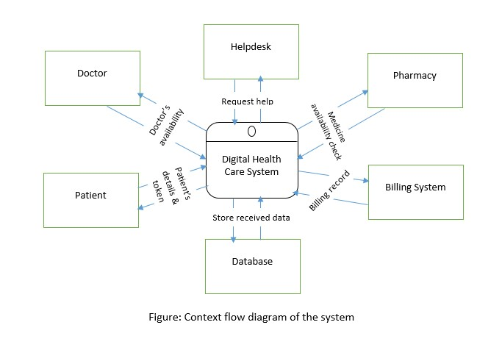

* **Display unit** – It will indicate the token of the current patient the doctor is seeing and so it will also indicate how long the patient has to wait.
* **Monitor** - It’s the frontend of the system where the patients will be able to operate the system and access all the features.
* **Processor** - For executing the instructions given by the patients, doctors, help desk manager and pharmacist and making the information up to date in the machine.
* **Printer** - For printing the token number which will correspond to the details about patients visit and the total bill.
* **Ethernet LAN** - To connect all the internal computers of the hospital like doctor’s computers, help desk computers, pharmacy computers.

### KEY TECHNICAL FEATURES OF SOFTWARE

In this system when a patient will come to get tokens from the machine then he/she will be asked for a patient id if he had visited in the same hospital before, then they will have a patient id which corresponds to all their details in the system. By this patient id number this machine keeps all the information about the patient like the reports of his/her test or another detail which are related to the hospital. If he/she doesn’t have any patient id then instantly the machine will ask him/her to give their name, id, address and mobile number then the machine will generate a patient id and gives it to the patient. Then the patient will see some features like doctors Consultancy, Help desk, any kind of test like blood test, x-ray, surgery information and pharmacy for medicines. If the patient needs to check up, then she will press on the consultancy button and it will open the list of doctors on call. Then patient will request for any doctors and press on the name of the doctor and then it will show the cost/ fees to test/checkup and request the patient to pay the amount to cash counter after getting the token. Then the patient will see some features like doctors Consultancy, Help desk, any kind of test like blood test, x-ray, surgery information and pharmacy for medicines After paying the total amount, cash counter manger will give this clearance information to the machine and the machine will be updated instantly and this will notify the doctor that this specific patient holding this token number has completed the payment and is coming to test/checkup. Then patient will request for any doctors and press on the name of the doctor and then it will show the cost/ fees to test/checkup and request the patient to pay the amount to cash counter after getting the token. Another other special feature is getting reports with the just the patient id by providing the patient id, patient can get their reports easily.

Every information is saved on database and then whenever machine needs any information then it will retrieve from the database and stores information in the database which relates to my proposed system. Thus, it is reducing customer waiting time and motion and improving the efficiency of the hospital as maximum activities will be done systematically by this Digital Health Care System.

#### SOFTWARE DETAILS

|  |  |  |
| --- | --- | --- |
| **Software Features** | | **Details** |
| Patients doctors | & | In this feature the system will keep all the record of the patients and doctors also. Whenever a patient will come to get tokens from the machine then he/she will be asked for a patient id if they had visited in the same hospital before, then they will have a patient id which corresponds to all their details in the system. By this patient id number this machine keeps all the information about the patient like the reports of his/her test or another detail which are related to the hospital. If he/she doesn’t have any patient id then instantly the machine will ask him/her to give their name, id, address and mobile number then the machine will generate a patient id and gives it to the patient. Then the patient will see some features like doctors Consultancy, Help desk, any kind of test like blood test, x-ray, surgery information and pharmacy for medicines. |
| Pharmacy |  | It is one of the useful features of the digital system which enables the patient to see whether their required medicines are available in the pharmacy of this hospital. |
| Helpdesk | | In this feature, the patient can also get any information related to the hospital or about any problem he/she is facing about medical issues. It will also generate the token to patient saying the room number of help desk. |
| Billing system | | This feature is added in this system to inform the patients about the total bill and to request them to pay it to the mentioned cash counter provided by machine. |

In the hospital, all the information is kept in a database. So, this system relates to this database system by which when machine wants to get any information it can retrieve it from the database and it also can up to date the information in the database whenever needed so that it works efficiently with respond to the patients and providing them service.

## SECTION 3

### INFORMATION GATHERING METHODS



There were three information gathering methods to elicit human information requirements from the organization members and the users. I have used the following methods: Interviewing, Surveying people through questionnaires and Sampling.

#### INTERVIEWING

An information gathering interview is a directed conversation with a specific purpose that uses question and answer format. As my project is based on hospital so I have tried to get the opinions of the hospital authorities and the patients about the current system state of the system and organizational and personal goals. As interviewing is the informal procedure for the interacting with information technologies so I have chosen this procedure to get my required information for my proposed system. Opinions are more important and more reveals than the fact. Because by seeking opinions rather than facts can be the productive procedure to discover the key problem of the owner and users want to address. So, I have done this to get the main problems they think they are facing. I have chosen some of the organization members and some the patients as my interviewee because the organizational members and the users face different types of problems from their perspective. Another thing I have emphasized on is knowing about the goals of the organization as I may not be able to determine goals through any other data gathering methods, so I have tried to figure out the goals of the organization by interviewing them. Questions regarding to the current system are asked and it’s asked in both open ended questions and closed ended questions. I have used open ended questions most because it provides richness of details and I need to know the organization and user’s problem very well so I have given their opportunity to tell me in detail about their problems and the requirements which they think they need in the new system.

There were five major steps in interview preparation:

**READING BACKGROUND MATERIAL**

It’s important to read and understand as much background information about interviewees and their organization as possible. This material can be obtained on the corporate website, from a current annual report, a corporate newsletter or publications sent out to explain the organization to public. So, I have read out the materials related to the organizations first. Thus, I have tried to build a common vocabulary that enabled me to phrase interview questions in a way that is understandable to my interviewee and saved my time than asking them about general background.

**ESTABLISHING INTERVIEWING BACKGROUND**

Already I have established my interview objectives using the information gathered. By this I have come to know about the HCI concerns like the usefulness and usability of the system; how it fits physical aspects: how it suits a user’s cognitive capabilities, decision making frequency and qualities of information.

**DECIDING WHOM TO INTERVIEW**

I have included key people of all the levels who will be affected by the system in some manner. So, I have interviewed some people from the organization and some of them who are the main users of the new system so that they can address their problems and the desired requirement from their own perspective.

**PREPARING THE INTERVIEWEE**

Preparing the interviewee is the most important thing to do before interviewing so that they can think about the interview. So, I have sent the interviewee email to come and sent some questions what I supposed to ask them, and they can prepare themselves properly.

**DECIDING ON QUESTION TYPES AND STRUCTURE**

Proper questioning techniques are the heart of interviewing. So, I have written some questions to cover the key areas of HCI areas and decision making and made some questions which are open ended by which they can express their feelings and opinions about the current system and the proposed system in detail. I also kept some close ended questions to summarize my interview session.

#### SURVEYING PEOPLE THROUGH QUESTIONNAIRES

The use of questionnaires is an information-gathering technique that allows systems analysts to study attitudes, beliefs, behavior, and characteristics of several key people in the organization who may be affected by the current and proposed systems. Attitudes are what people in the organization say they want in a new system, beliefs are what people think is true; behavior is what organizational members do and characteristics are properties of people or things. Questionnaires can be used to survey a large sample of system users to sense problems or raise important issues before interviews are scheduled. So, I have used questionnaires to conduct survey on the patients and the hospital authorities to know about their opinion about current system and the proposed system as hospital is the large sample of system. To gather information more effectively I needed to know what they want, so I conducted a survey on the people of the hospital who are affected by the current system of the hospital and with the new system.

**ACTIVITIES PERFORMED FOR SURVEYING: QUESTIONNAIRE**

Questionnaire is the quick way to gather massive amount of information about how users (patients) assess the current system, about what problems they are facing with their work and about what people expect from a new system. For getting this kind of information, I have done surveying on the people of the hospital organization and the users of the system (current and new system). I have written some questions to survey on them. The questions were transparently clear to them. I have made the questions to know their feelings more accurately and made the questions vocabulary easy so that I can communicate with the people by comfortable questions and using easy English structure helped them to understand the question and mark answers. I made some questions open ended and some of them were close ended and placed the most important questions first. I also followed some structure of making questionnaire considering leniency, central tendency and halo effect. Here is a template of a questionnaire I have made for doing survey:

1. Gender:

a) Male b) Female

2. Age:

a) Less or equal 15 b) 16-25 c) 26-35 d) 36-45 e) Over 45

3. Education:

a) Masters/MBA/Post Graduate b) Graduate c) HSC d) SSC

e) Others (Please specify) ___________________________

4. Occupation:

a) Student b) Business c) Govt. Employee d) Private Employee

e) Other (Please specify) _____________________________

5. Average monthly income (BDT):

a) Less or equal 15,000 b) 15,001-25,000 c) 25,001-45,000 d) 45,001-65,000 e) Above 65,000

6. What do you think about DHCS System?

a) Reliable b) Good Performance

c) Durable

e) Others (Mention please) ………………………

1. Place your belief on system:

Good Service ______ ______ ______ ______ ______ Poor Service

More Durable ______ ______ ______ ______ ______ less Durable

Friendly ______ ______ ______ ______ ______ Not

Friendly

1. How do rate the current system (manual token system)?

A) Good b) Better c) Average d) Worst

9. Do you think the system should change?

a) Yes b) No

1. What kind of features do you need which are different from the current system?

Explain……………………

1. Will you feel comfortable to operate any technical machine?

a) Yes b) No

12. Do you think automated token system can save your time?

a) Yes b) No

13. What kind of problem you are facing with the current system?

Please explain -

#### SAMPLING

Sampling is the process of systematically selecting representative elements of a population. When these selected elements are examined closely, it is assumed that the analysis will reveal useful information about the population. There are many reports, forms, output documents, memos, and Web sites that have been generated by people in the organization. So, I needed to know which people I need to interview, seek information from via questionnaires, or observe in the process of carrying out their decision-making roles. All those problems solved by sampling. As I am working on the hospital based project so there are lots of paper activities and lengthy process to do like examining every scrap of paper, talking with everyone, and reading every Web page from the organization is too costly to me. Another thing is copying reports, asking employees for valuable time, and duplicating unnecessary surveys would result in much needless expense. As sampling helps to accelerate the process by gathering selected data rather than all data for the entire population, so I have used this process to improve the effectiveness of my system. By following sampling method, I just needed to talk to fewer people but asked them questions that are more detailed. That’s why I have got the time to follow up on missing or incomplete data, thus improving the effectiveness of data gathering. In my project sampling is basically helping the hospital authorities.

**ACTIVITIES PERFORMED FOR SAMPLING METHOD**

**Determining the Data to Be Collected**

As I have gathered information and data already, so I had plan about what will be done with the data. If irrelevant data are gathered, then time and money are wasted in the collection, storage, and analysis of useless data. So, I needed to identify the variables, attributes, and associated data items that need to be gathered in the sample. Interviewing, investigation, questionnaire and observation are also needed to apply sampling method. I have interviewed the organizational members and the patients about their opinions and requirements in the proposed system.

**Determining the population to be sampled**

In this step I determined what the population would be selected to sample. In the case of hard data, I decided the required timing of my project if it’s the sufficient time for completing my analysis, in this step I prepared me in deciding whom to interview and whether the population should include only one level in the organization or all the levels, or maybe I should even go outside of the system to include the reactions of customers and the organizational member or another people who are outside of my project.

**Choosing the Type of Sample**

There are four types of sample these are: convenience, purposive, simple, and complex. Convenience samples are unrestricted, nonprobability samples. In my project I have used stratified sampling. Because stratification is the process of identifying subpopulations, or strata, and then selecting objects or people for sampling in these subpopulations. Stratification is essential to gather data efficiently. If I want to seek opinions from a wide range of employees on different levels of the organization, systematic sampling would select a disproportionate number of employees from the operational control level. A stratified sample would compensate for this. For this reason, I have chosen stratified sampling because I must get information from the wide range of people from organization (hospital) authorities and patients.



**MAJOR FUNCTIONALITIE**

**S OFFERED BY THE**

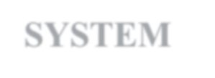

**SYSTEM**



**USE CASE DIAGRAM**

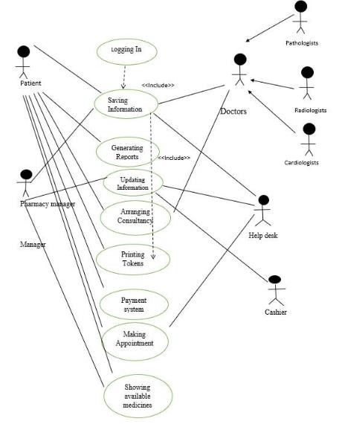

Figure: Use case diagram of the software.

### NORMAL SCENARIOS FOR USE CASES



|  |  |
| --- | --- |
| **Use case name:** Arranging consultancy | |
| **Actor:** Users/patients | |
| **Description:** Allows to see the doctors name and appointment time  Scheduling and the test features. | |
| **Triggering Event:** Patient uses Automated Token System machine, enters Id and presses on the button he/she wants to access according to his/her health issue. | |
| **Steps Preformed** | **Information for Steps** |
| 1. Patient logs in the system with secure LAN connection. | 1. Patient ID |
| 2. Patient can see the options and choose the option pressing on the button | 2. Patient ID |
| **Preconditions:** Patient should be present physically to access the system. | |
| **Post conditions:** Patient has successfully chosen his/her required consultancy. | |
| **Assumption:** Patient has valid id and knows how to operate the system. | |

|  |  |
| --- | --- |
| **Use case name:** Generating Token | |
| **Actor:** Users/patients | |
| **Description:** Generating tokens according to the given information of the patients. | |
| **Triggering Event:** Patient uses DHCS machine and wants specific token regarding patient’s health issues and the machine generates token | |
| **Steps Preformed** | **Information for Steps** |
| 1. Patients Logs in the system. | 1. Patient ID |
| 2. Patient record is read, and machine generates token of specific issue | 2. Patient Id, Patient record |
| **Preconditions:** Patient should be present physically to access the system and system has no technical problem. | |
| **Post conditions:** Generates token successfully and delivers to the patient. | |
| **Assumption:** The system is up to date with the given information. | |

|  |  |
| --- | --- |
| **Use case name:** Pharmacy | |
| **Actor:** Users/patients | |
| **Description:** Allows the users to see the medicines available in the hospital. | |
| **Triggering Event:** Patient uses DHCS machine and wants token if the required medicine is available in the hospital. | |
| **Steps Preformed** | **Information for Steps** |
| 1. Patients Logs in the system. | 1. Patient ID |
| 2. Patient record is read, and machine generates token of specific issue | 2. Patient Id, Patient record |
| **Preconditions:** Patient should be present physically to access the system and system has no technical problem. | |
| **Post conditions:** Generates token successfully and delivers to the patient. | |
| **Assumption:** The system is up to date with the given information. | |

|  |  |
| --- | --- |
| **Use case name:** Help Desk | |
| **Actor:** Users/patients | |
| **Description:** Allows to get tokens to help users from the help desk. | |
| **Triggering Event:** Patient uses DHCS machine and wants specific token regarding patient’s health issues and the machine generates token. | |
| **Steps Preformed** | **Information for Steps** |
| 1. Patients Logs in the system. | 1. Patient ID |
| 2. Patient record is read, and machine generates token of specific issue | 2. Patient Id, Patient record |
| **Preconditions:** Patient should be present physically to access the system and system has no technical problem. | |
| **Post conditions:** Generates token successfully and delivers to the patient. | |
| **Assumption:** The system is up to date with the given information. | |

### ALTERNATE SCENARIOS FOR USE CASES



|  |  |
| --- | --- |
| **Use case name:** Online Appointment System | |
| **Actor:** Users/patients | |
| **Description:** Allows to take appointment via Internet. | |
| **Triggering Event:** Patient uses DHCS machine through Internet, enters id and clicks on the button patients want to access for getting appointment. | |
| **Steps Preformed** | **Information for Steps** |
| 1. Patients Logs in the system. | 1. Patient ID |
| 2. Patient record is read, and machine generates token of specific issue | 2. Patient Id, Patient record |
| **Preconditions:** Patient has already logged in to the machine through Internet. | |
| **Post conditions:** Patient has successfully got token number of their expected appointment according to their health issue. | |
| **Assumption:** Patient has internet connection and logged in to the system | |

|  |  |
| --- | --- |
| **Use case name:** Credit card System | |
| **Actor:** Users/patients | |
| **Description:** Allows to pay fees by smart payment card. | |
| **Triggering Event:** Patient uses DHCS machine, enters id and clicks on their required heath issue related options and takes appointment and machine shows the total cost then patients proceed on. | |
| **Steps Preformed** | **Information for Steps** |
| 1. Patients Logs in the system. | 1. Patient ID |
| 2. System shows the total cost of the appointment. | 2. Patient Id, Patient record |
| **Preconditions:** Patient has already logged in to the system and has credit card. | |
| **Post conditions:** Patient has successfully paid the total cost of their expected appointment according to their health issue. | |
| **Assumption:** Patient has credit card and logged in to the System. | |

|  |  |
| --- | --- |
| **Use case name:** Guest | |
| **Actor:** Users/patients | |
| **Description:** Allows to buy medicines without id and password. | |
| **Triggering Event:** Patient uses ATS machine, clicks on the guest login then it shows the available medicines and system generates token to guest user to buy required medicines. | |
| **Steps Preformed** | **Information for Steps** |
| 1. Patients choose medicine to get token of their required medicine. | 1. medicine file record |
| 2. System shows the total cost of the medicine. | 2. medicine file record |
| **Preconditions:** Patient must be physically present to access the machine and the system has no technical error. | |
| **Post conditions:** Patient has successfully bought their expected medicines. | |
| **Assumption:** Patient has credit card and logged in to the System. | |

### FUNCTIONAL REQUIREMENTS



A functional requirement is a function or feature that must be included in an information system to satisfy the business need and be acceptable to the users. The functional requirements for my project are:

* The digital system shows the log in and sign up form and allows the users to log in to the system.
* The DHCS generates ID and Users get logged into system by the ID.
* With the ID number the system determines if patients had visited in the same hospital before, it shows all their details in the system. By this patient id number this system keeps all the information about the patient like the reports of his/her test or another detail which are related to the hospital. If he/she doesn’t have any patient id then instantly the DTS system will ask him/her to give their name, id, address and mobile number then the system will generate a patient id and gives it to the patient.
* After logging in the system, it allows the customer to see all the features of the system. The patient can see some features like doctors Consultancy, Help desk, any kind of test like blood test, x-ray, surgery information and pharmacy for medicines.
* If the patient needs to check up, then she can press on the consultancy button and it will open the list of doctors on call and the time scheduling of the doctors. Then patient can request for any doctors and press on the name of the doctor and then it will show the cost/ fees to test/checkup and request the patient to pay the amount to cash counter after getting the token.
* The DHCS machine generates token for every feature it saves the patient’s time and makes the patient’s life easier.
* The patient can also get any information related to the hospital or about any problem he/she is facing about medical issues through the help desk feature.
* DHCS system enables the patient to see whether their required medicines are available in the pharmacy of this hospital. Thereafter patient can decide what is his/her next course of action rather not being physically present there. After the confirmation of the machine the patient gets a token number and buy it.
* The system allows the customer to access the features.
* This DHCS system also generates reports of medical issues by which patient feel comfortable in receiving reports.
* This machine also helps the cashier of the hospital because this system shows the total cost when a patient request for any appointment that’s why first patients have to confirm if he/she will proceed on with the cost then he makes his payment clearance from the cash counter.
* The most important requirement of this machine is generating token for the users about their desired requirements.
* It will help to get the tokens quickly to patients.
* Patients, doctors, help desk manager and pharmacy manager can access the system.
* Organization can change their information regarding themselves.
* This machine may have the online appointment procedure if the users need it. (if Alternatives case happens)
* This machine can also give opportunity to pay the cost by their credit card. (if Alternatives case happens)

### NON-FUNCTIONAL REQUIREMENTS



A nonfunctional requirement is a description of the features, characteristics, and attributes of the system as well as any constraints that may limit the boundaries of the proposed solution. The non-functional requirements for my project are given below:

1. **Performance:** The DHCS will provide better performance. Performance requirement represents the performance. The system is required to exhibit to meet the need of users. The response time of the DHCS system should be quicker to save the time and it ensures patients life easier.
2. **Information:** Information is an important resource. It represents the information that is pertinent to the users in terms of content, time accuracy and format. All the information will be kept in the DHCS system.so that when the patient will come to the hospital for the several times, then he/she will get all the details about their medical issues saved in the database of the machine and all the information should be updated with the time like when a patient is testing any blood test or consultancy then he/she will pay the cost of it which will paid by the customer to the cash counter and cash counter will update the information in the DHCS that the patient has already completed the billing and is eligible to visit the doctors/ tests. A customer will also be able to show the features included in the machine.
3. **Control and Security-** The information will be automatically saved in the database of the DHCS. The control unit of accessing the details of the machine is the administrator of the machine. It ensures the data accuracy and data security.
4. **Efficiency –** DHCS enable the ability to produce outputs with minimal waste. As the machine is giving token which is automated so it’s more efficient than the previously used system which was manual system. As it is an automated system, so there is no chance to get repeating things. Moreover, it’s efficient because all the information is kept or stored in the DHCS. So, doctors, pharmacy manager, help desk manager and cashier get rid of doing their monotonous job of sorting data manually. So, it gives more comfort to the people related in this DHCS.
5. **Service –** The system will be reliable, flexible and expandable. The patients, doctors, help desk manager, cashier and the pharmacy manager will use this machine and it will be in the hospital and there are different users like the doctors who are giving information about their schedule of their appointment timings and on call timings to the machine and the patients who are requesting about their requirements about their health issues. Maintenance will be provided to use the machine for the first time.
6. **Reliability –** The system should be extremely reliable to users and secure so that information about hospital and patient’s personal information can’t be leaked by the third party or the external people of the organization.
7. **Usability –** DHCS should be user friendly and should require least effort to operate so it will make patients life easier.
8. **Availability –** As this DHCS machine is in the hospital so it’s available when user enters in the hospital, it can be accessed 24/7 hours.
9. **Ease of use-** This machine is easy to operate so it enables user in interacting with the machine and user can use the system with ease.



## SECTION 4

### ENTITY RELATIONSHIP DIAGRAM



An entity relationship model, also called an entity-relationship (ER) diagram, is a graphical representation of entities and their relationships to each other, typically used in computing in regard to the organization of data within databases or information systems.

The Entity Relationship Diagram of my system is given below:

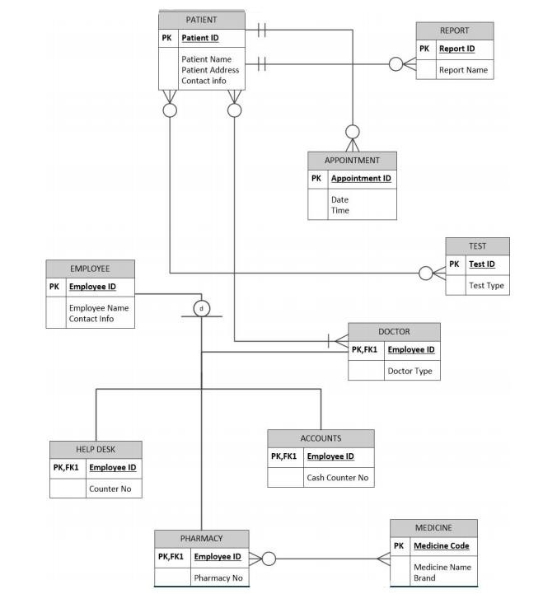

### LOGICAL DATA FLOW DIAGRAM



A logical DFD captures the data flows that are necessary for a system to operate. It describes the processes that are undertaken, the data required and produced by each process, and the stores needed to hold the data.

The Logical Data Flow diagram of my system is given below:

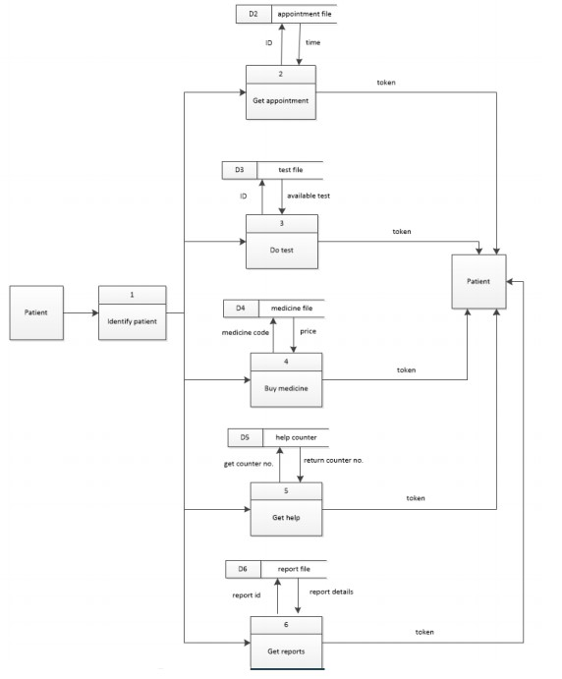

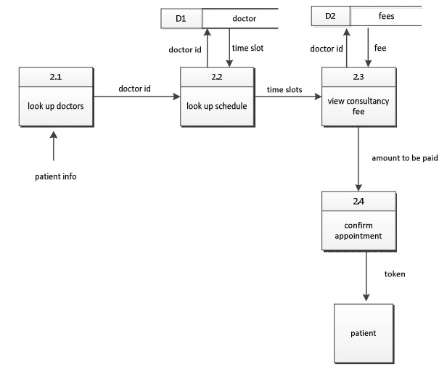

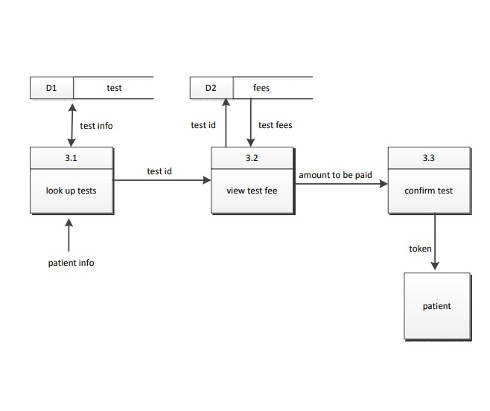

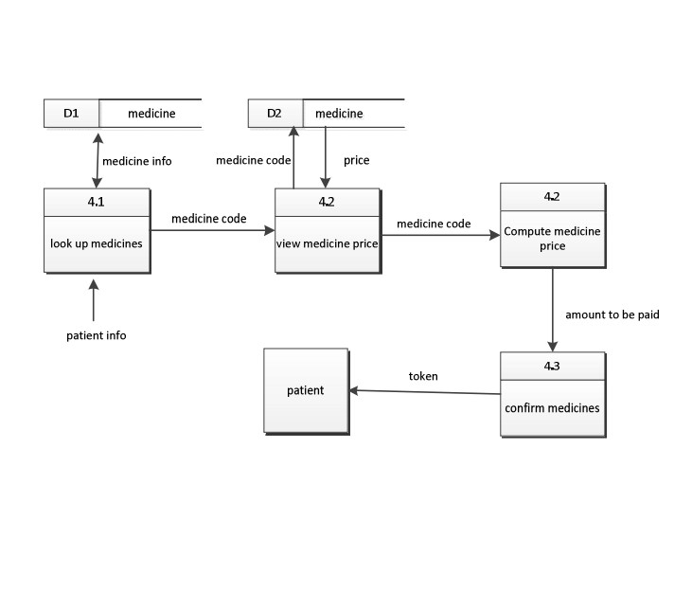

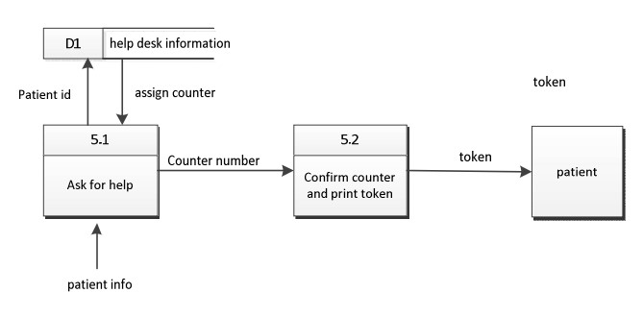

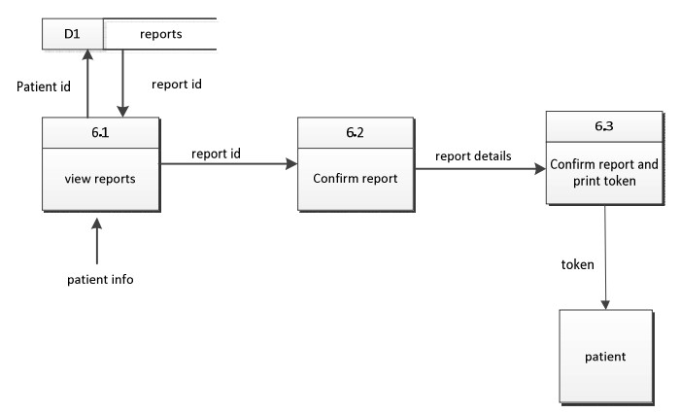

### PHYSICAL DATA FLOW DIAGRAM



A logical DFD focuses on the business and business activities, while a physical DFD looks at how a system is implemented. So while any data flow diagram maps out the flow of information for a process or system, the logical diagram provides the “what” and the physical provides the “how.”

The Physical Data Flow diagram of my system is given below:

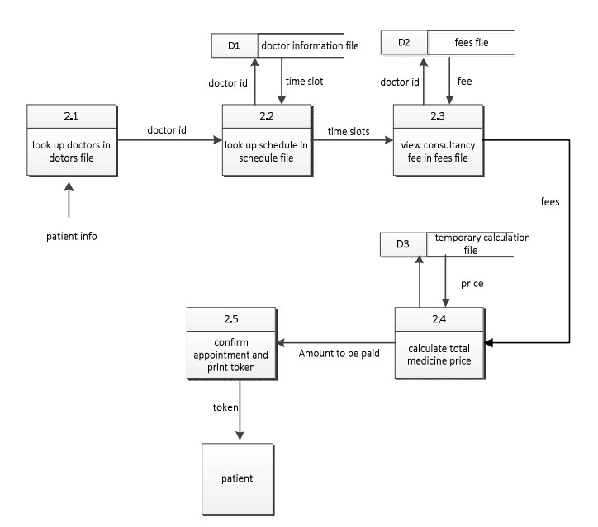

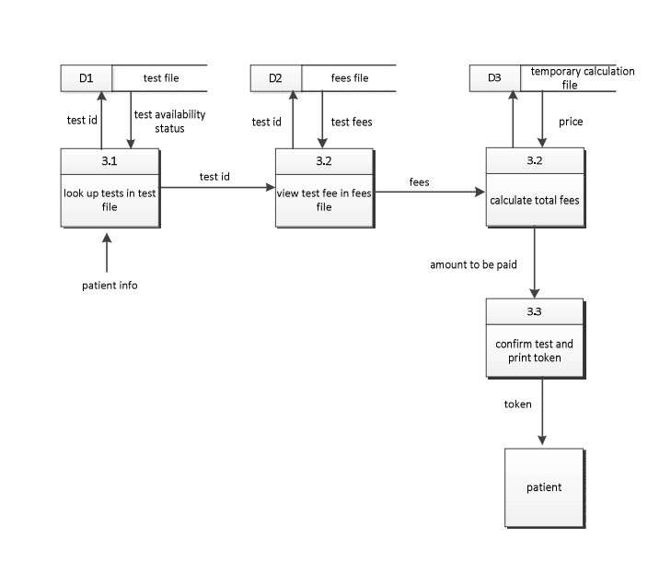

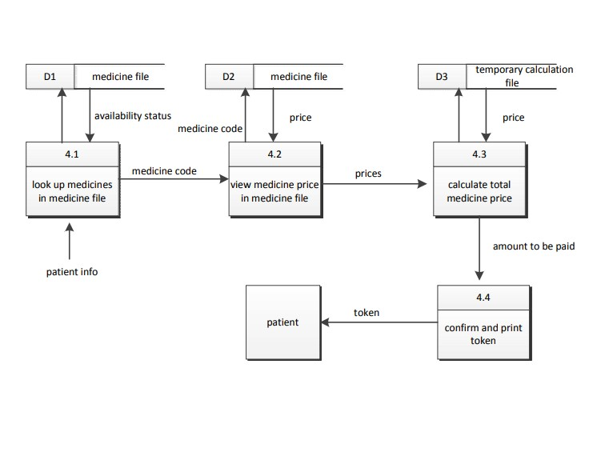

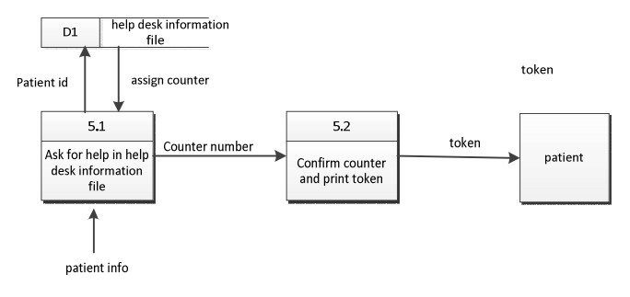

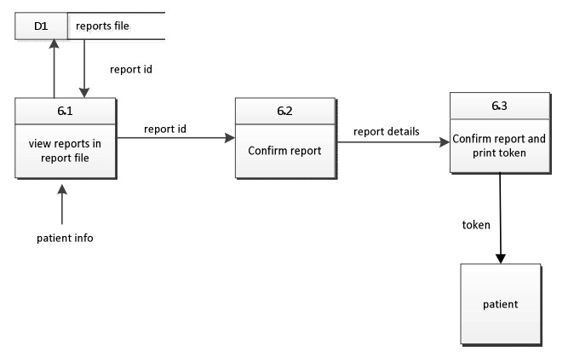

### ACTIVITY DIAGRAMS FROM USE CASE DIAGRAMS



Activity diagram is another important diagram in UML to describe the dynamic aspects of the system. Activity diagram is basically a flowchart to represent the flow from one activity to another activity. The activity can be described as an operation of the system. The control flow is drawn from one operation to another.

The Activity Diagrams of my system is given below:

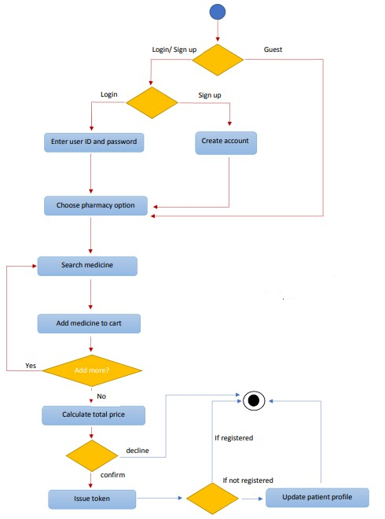

Figure: Showing how a patient can buy medicines from the pharmacy using the System.

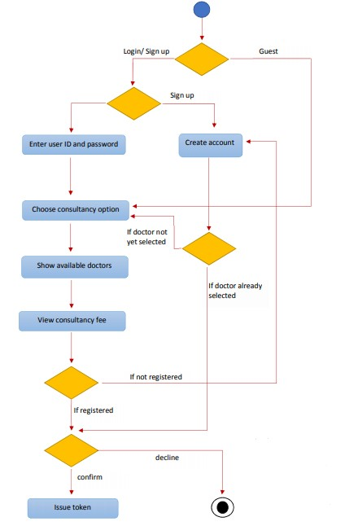

Figure: The figure depicts how a patient can get an appointment with the doctor through the system.

### SEQUENCE AND COMMUNICATION DIAGRAMS



#### SEQUENCE DIAGRAM

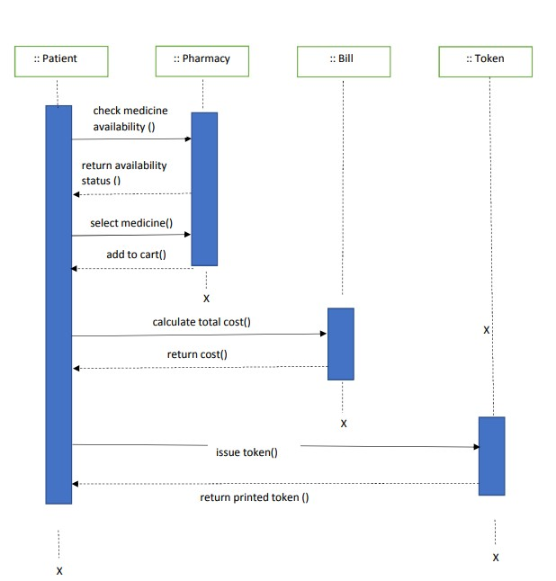

Figure: showing how a patient can buy medicines from the pharmacy.

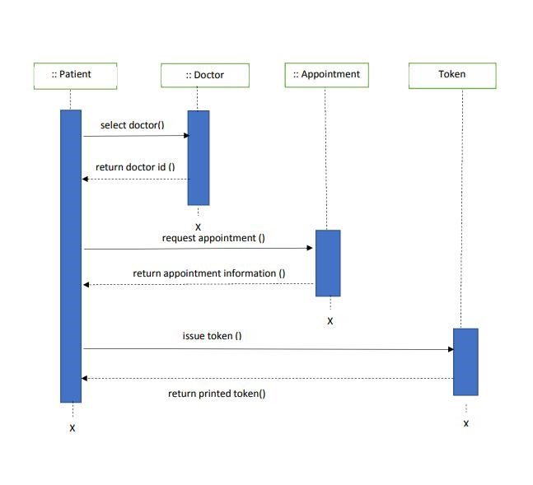

Figure: Sequence diagram showing the process of getting an appointment.

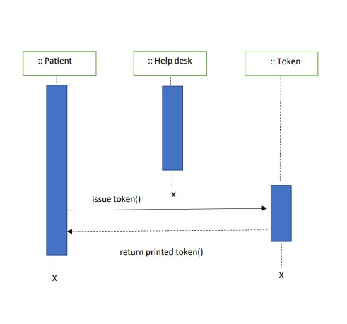

Figure: showing how a patient can get help from help desk.

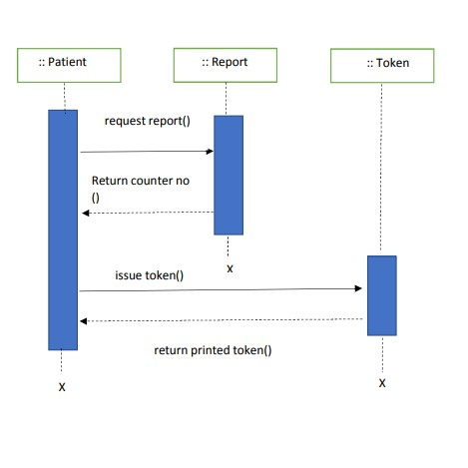

Figure: showing how a patient can get report from report counter.

#### COMMUNICATION DIAGRAM

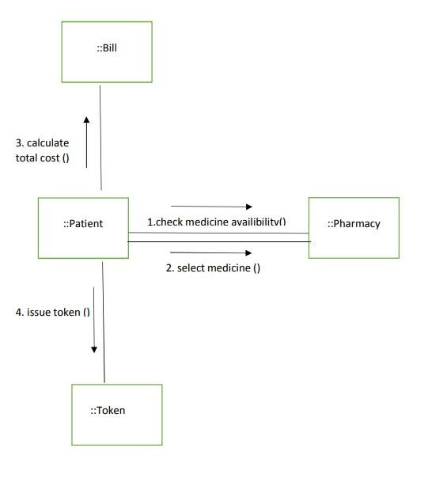

Figure: showing how a patient can buy medicines from the pharmacy.

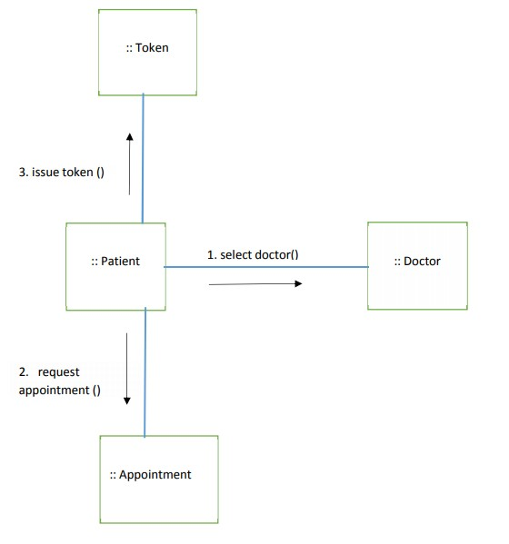

Figure: Communication diagram of getting an appointment. Communication and sequence diagram can be interchanged.

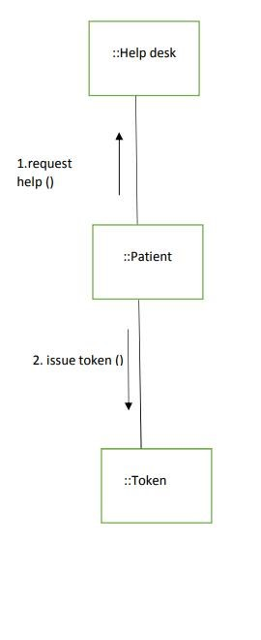

Figure: showing how a patient can get report from report counter using the system.

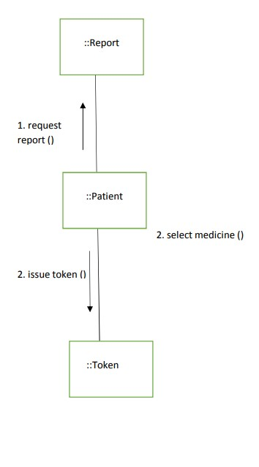

Figure: showing how a patient can get report from report counter using the system.

### CLASS DIAGRAMS

A class diagram in the Unified Modeling Language (UML) is a type of static structure diagram that describes the structure of a system by showing the system's classes, their attributes, operations (or methods), and the relationships among objects.

The Class Diagram of my system is given below:

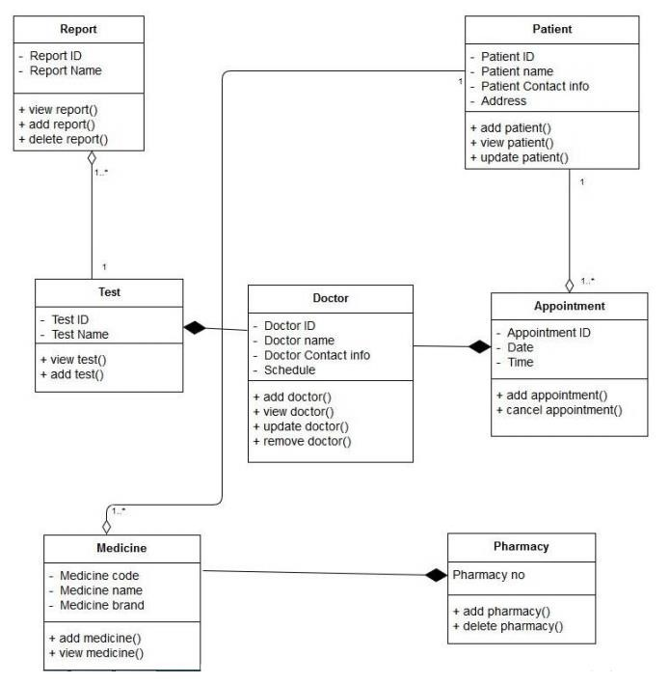

### STATE CHART DIAGRAMS



A state diagram, also called a [state machine](https://whatis.techtarget.com/definition/state-machine) diagram or state chart diagram, is an illustration of the states an object can attain as well as the transitions between those states in the Unified Modeling Language (UML).

The state chart diagrams of my system is given below:

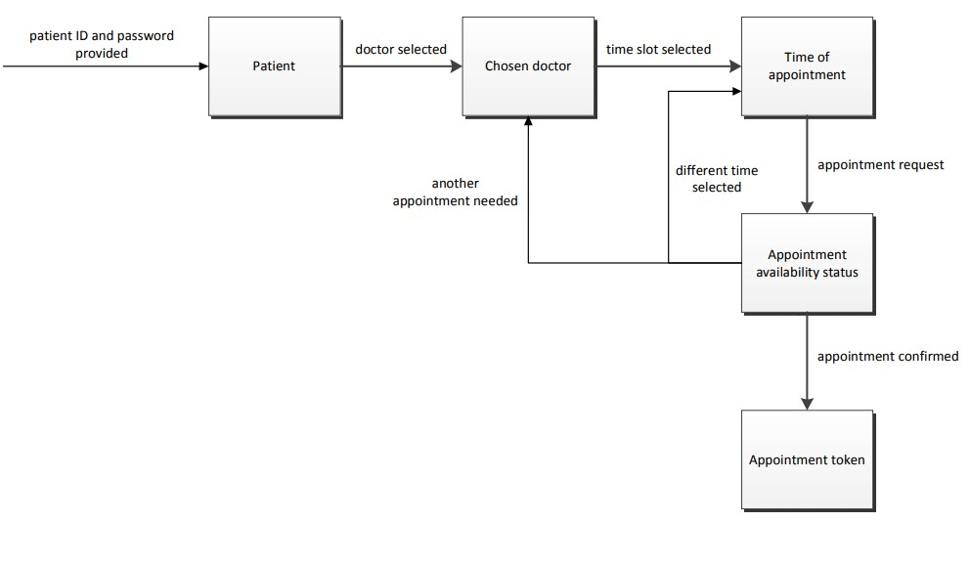

Figure: This state chart diagram shows how a patient can get a token for a test.

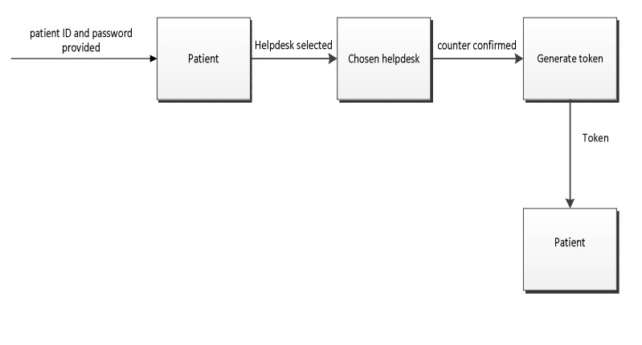

Figure: Different states that the patient has to go through in order to get an appointment.

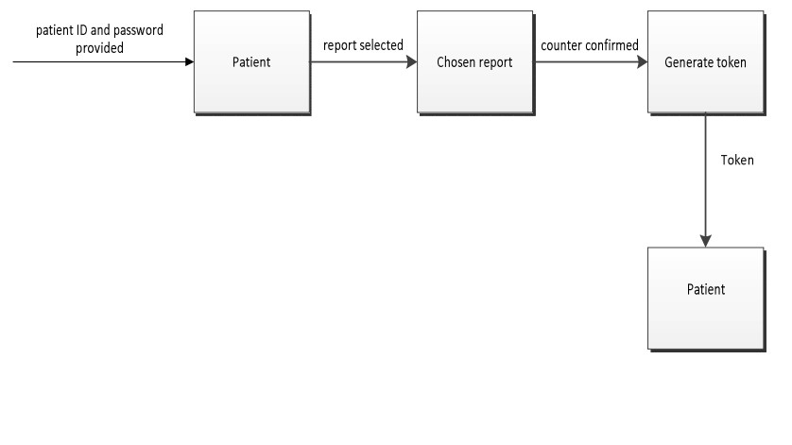

Figure: This state chart diagram shows how a patient can get a token for getting help.

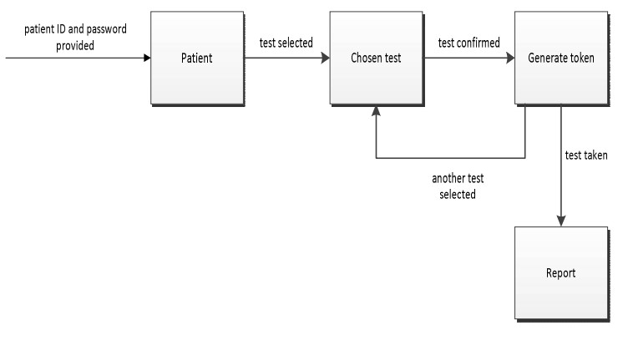

Figure: This state chart diagram shows how a patient can get a token for getting report.

### CRUD MATRIX



|  |  |  |  |  |  |  |  |  |
| --- | --- | --- | --- | --- | --- | --- | --- | --- |
| **Activity** | **Patient** | **Doctor** | **Appointment** | **Bill** | **Medicine** | **Test** | **Report** | **Token** |
| **Patient Logon** | R |  |  |  |  |  |  |  |
| **Doctor Inquiry** |  | R |  |  |  |  |  |  |
| **Get Appointment** |  |  | C |  |  |  |  | C |
| **Cancel Appointment** |  |  | D |  |  |  |  |  |
| **Search medicine** |  |  |  |  | R |  |  |  |
| **Buy Medicine** |  |  |  | C |  |  |  | C |
| **Search Test** |  |  |  |  |  | R |  |  |
| **View Report** |  |  |  |  |  |  | R | C |
| **Add Report** |  |  |  |  |  |  | C |  |
| **Delete Report** |  |  |  |  |  |  | D |  |
| **Change Doctor Information** |  | RU |  |  |  |  |  |  |
| **Add doctor** |  | C |  |  |  |  |  |  |
| **Add patient** | C |  |  |  |  |  |  |  |
| **Change Patient Information** | RU |  |  |  |  |  |  |  |



**SECTION 5**



**STRUCTURED ENGLISH P**

**SEUDO CODE FOR THE**



**SYSTEM**



**FOR GETTING APPOINTM**

**ENT**

DO

Until Token not printed or not cancelled IF doctor is available

AND

Timeslot is available,

UPDATE Appointment Print Token ELSE IF doctor is available

AND

timeslot is not available

DISPLAY choose another time slot

ELSE

DISPLAY Doctor not available

END IF END DO

#### PHARMACY

DO

UNTIL Token not printed or not cancelled IF medicine is available

ADD medicine to cart

ElSE

DISPLAY medicine not available

IF checked out

UPDATE medicine

Print Token

#### TEST

DO

UNTIL Token not printed or cancelled.

IF

Test is available

END IF

IF confirmed Print Token

END IF

END DO

### NORMALIZED RATIONAL DATABASE TABLES



**Patient ID** Patient Name, Address, Contact info

**Appointment ID** Date, Time, Patient ID, Name, Address contact info

**Report Id** Report Name, Contact Info, Employee Type

**Medicine code** Medicine Name, Brand

**Test ID** Test Type, Patient ID, Report ID, Report Name

**1NF R1**

|  |  |  |  |  |  |  |
| --- | --- | --- | --- | --- | --- | --- |
| Appointment ID | DATE | Time | PID | PName | PAddress | Contact info |

**R2**

|  |  |  |  |
| --- | --- | --- | --- |
| Employee ID | Employee Name | Contact Info | Employee Type |

**R3**

|  |  |  |
| --- | --- | --- |
| Medicine Code | Medicine Name | Brand |

**R4**

|  |  |  |  |  |
| --- | --- | --- | --- | --- |
| Test ID | Test Type | Patient ID | Report ID | Report Name |

**2NF**

There is no partial dependency. Therefore, the tables are already in 2NF.

#### 3NF

**R11**

Appointment ID

DATE

Time

PID

**R12**

PID

PName

PAddress

Contact info

**R41**

Test ID

Test Type

Report

ID

**R42**

Report ID

Report Name

**R2**

|  |  |  |  |
| --- | --- | --- | --- |
| Employee ID | Employee Name | Contact Info | Employee Type |

**R3**

|  |  |  |
| --- | --- | --- |
| Medicine Code | Medicine Name | Brand |



**INTERFACE PROTOTYPIN**

**G**

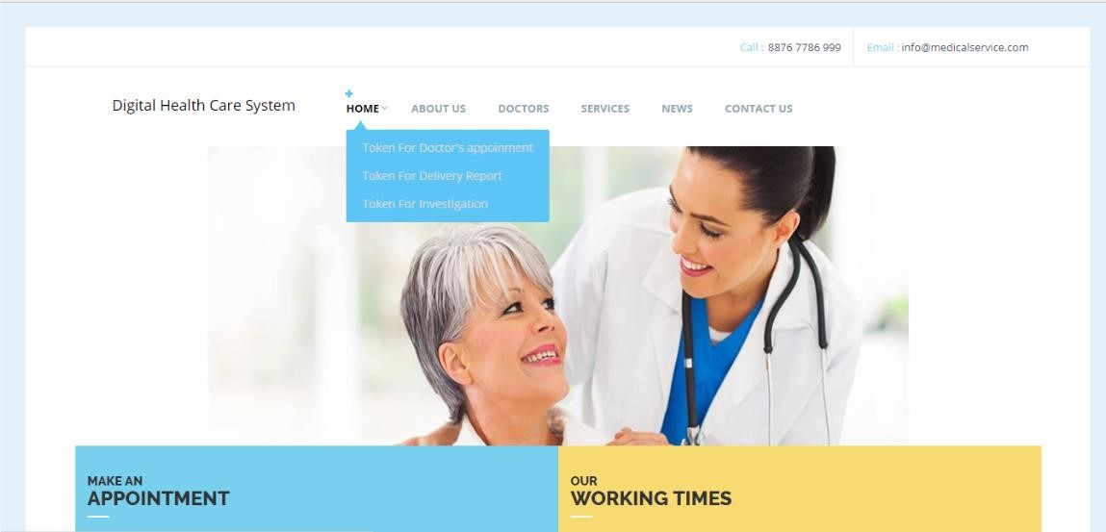

This is very first page of the software. The user will be presented with this screen when he/she first uses this software.

If the user already has an account or wants to create one, then he /she will have to click the first option. If the user just wants to access the pharmacy or wants to know any information about the hospital, then he/she can click on the guest option.

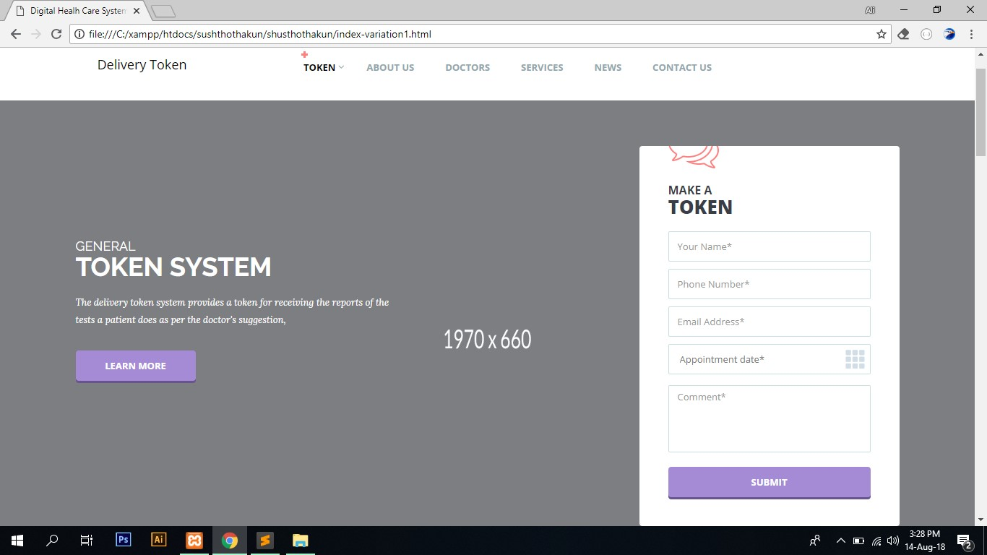

These are the options that the users can use with their account, which are appointment, tests, pharmacy, reports and help desk. By clicking on the appointment, user will be directed to the page where he/she will be able to choose the doctors and time of appointment.

Test option is used to perform some lab test. User can buy medicine using the pharmacy option. If any reports are available for the user, then it can be accessed through the report option. Lastly, help desk is used to get a token for getting any kind of help from the hospital help desk.

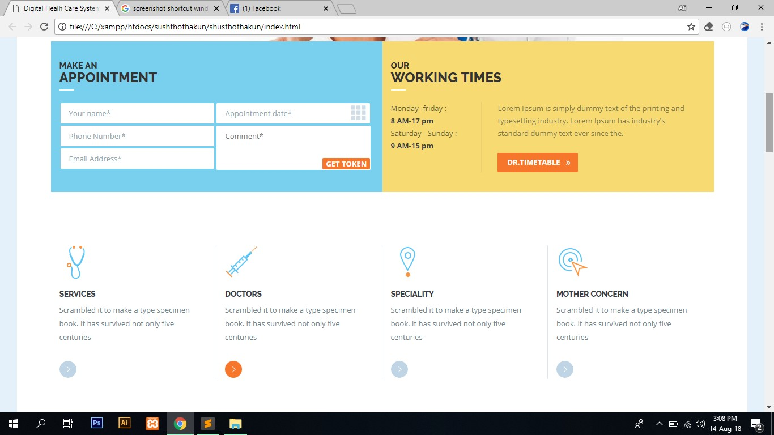

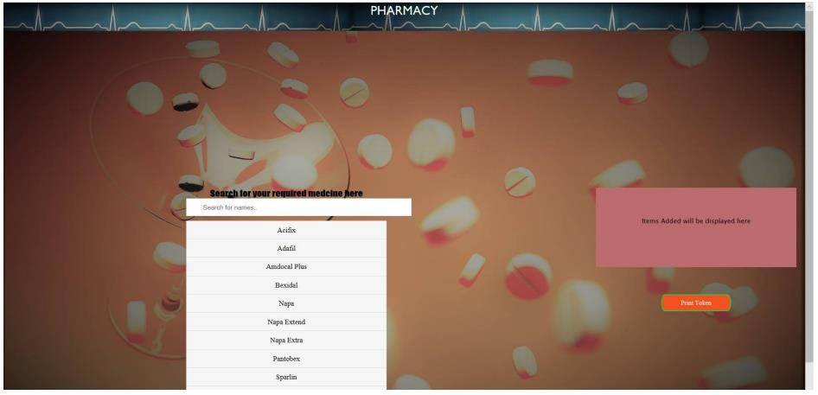

Above is the pharmacy page where the user can search for medicines and print a token to get those medicine from the store.

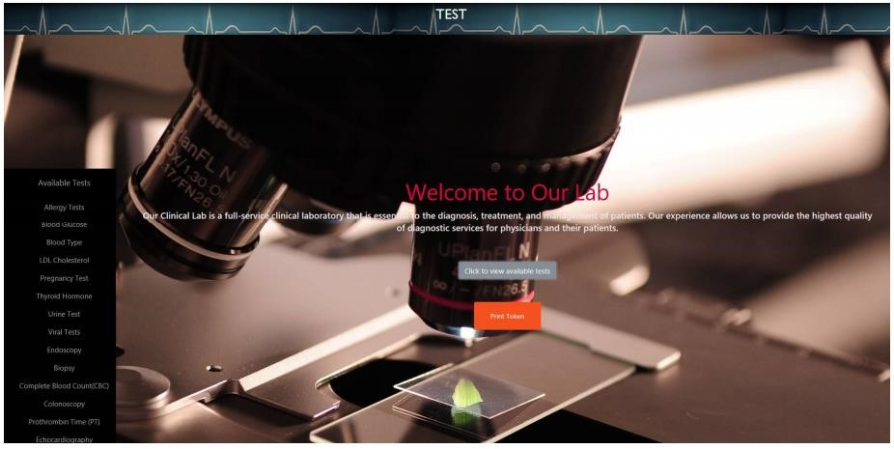

To perform any kind of test, the user can click the view available tests and see what test are available. When the user is done with selecting the test, he/she can click on the print token to generate a token for the tests.

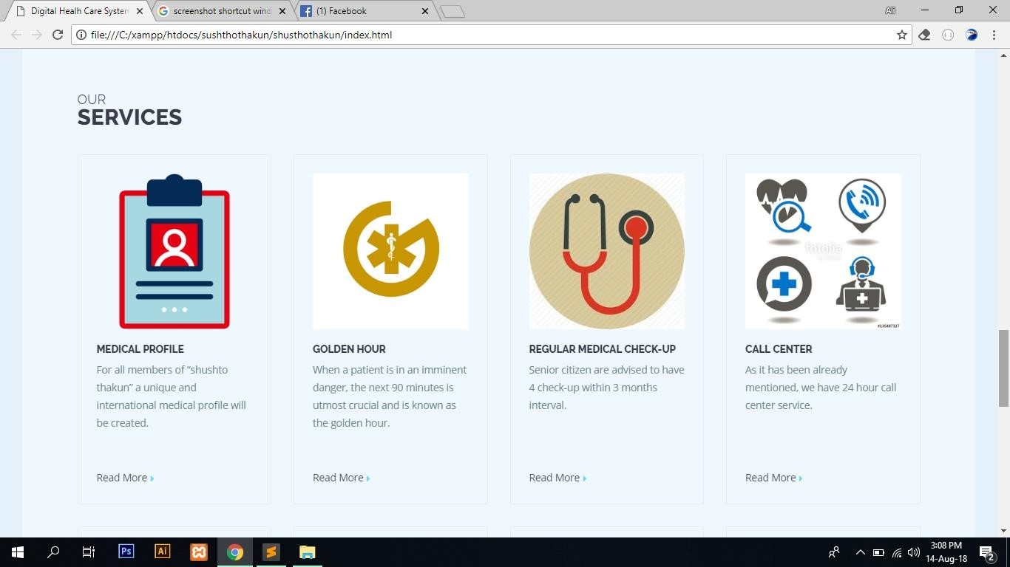

The other services of our digital health care system.